**HOME PAGE**

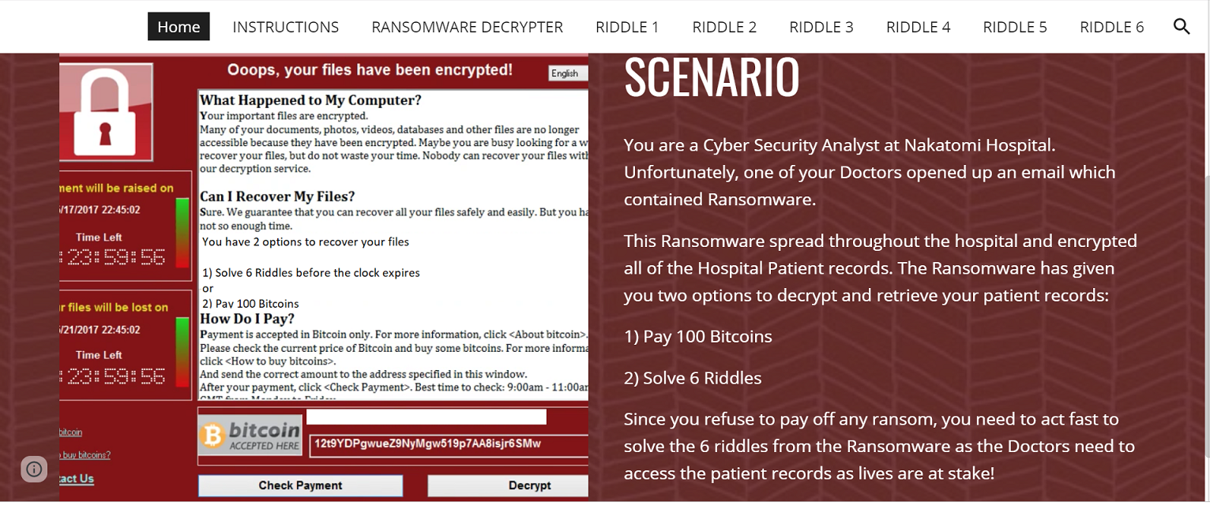

**Instructions:**

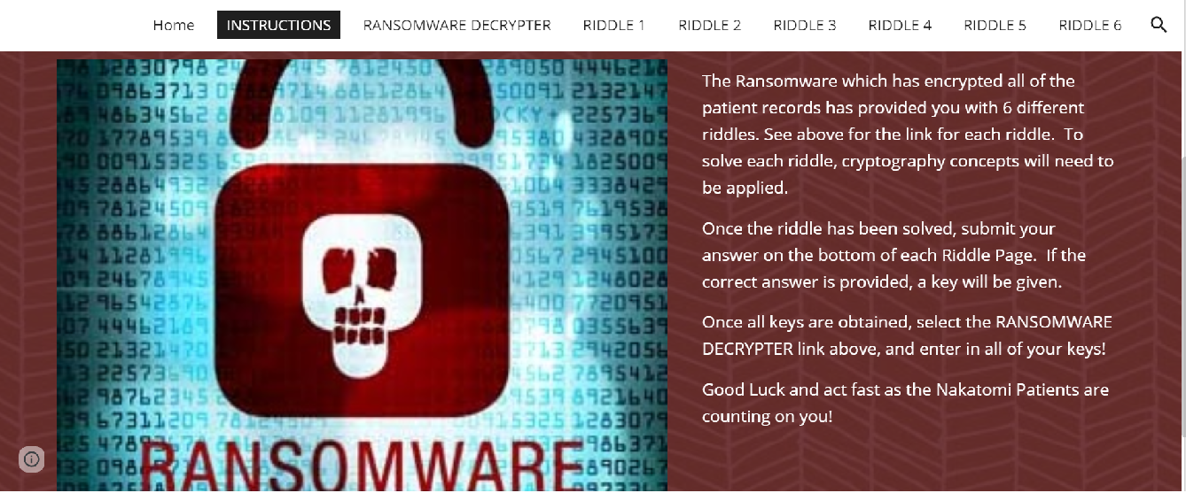

**RIDDLE 1:**

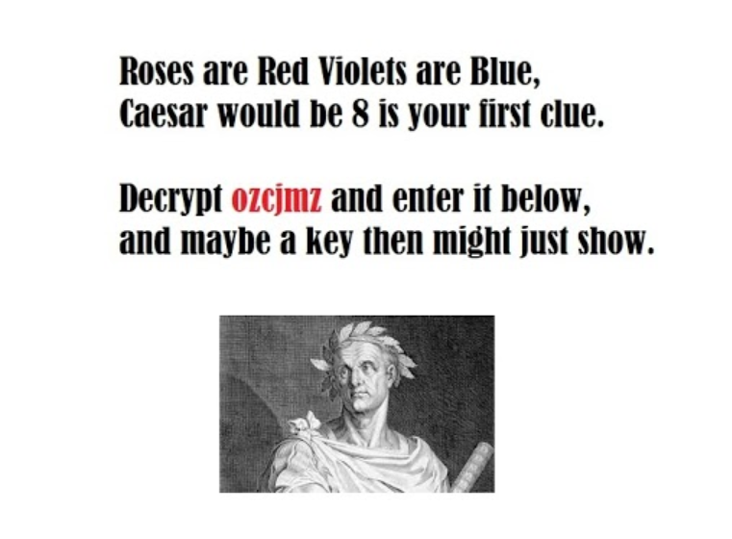

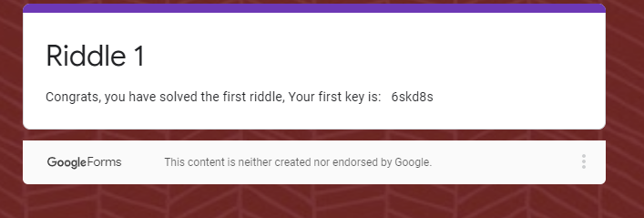

key is: 6skd8s

**RIDDLE 2:**

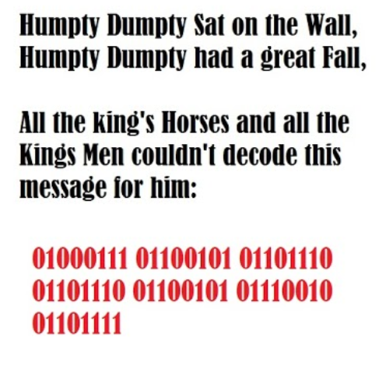

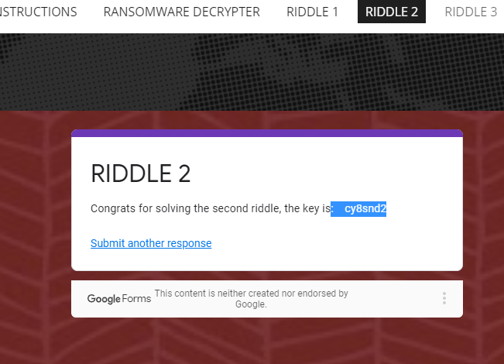

**Key :** cy8snd2

cy8snd2

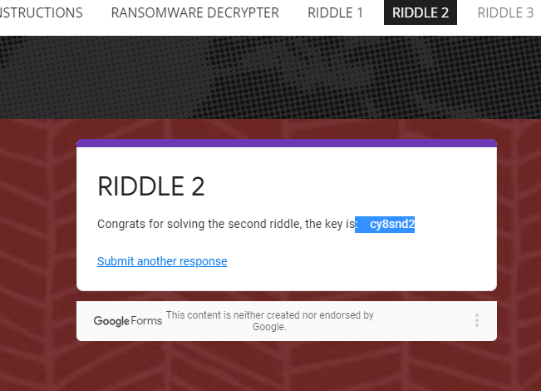

**Key: cy8snd2**

**RIDDLE 3:**

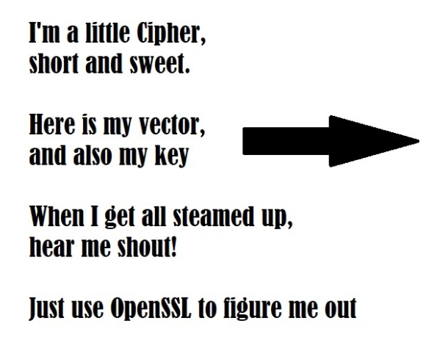

Cipher Text:

4qMOIvwEGXzvkMvRE2bNbg=

Key:

5284A3B154D99487D9D8D8508461A478C7BEB67081A64AD9A15147906E8E8564

IV (Initialization Vector):

1907C5E255F7FC9A6B47B0E789847AED

OpenSSL Options:

* -pbkdf2
* -nosalt
* -aes-256-cbc
* base64

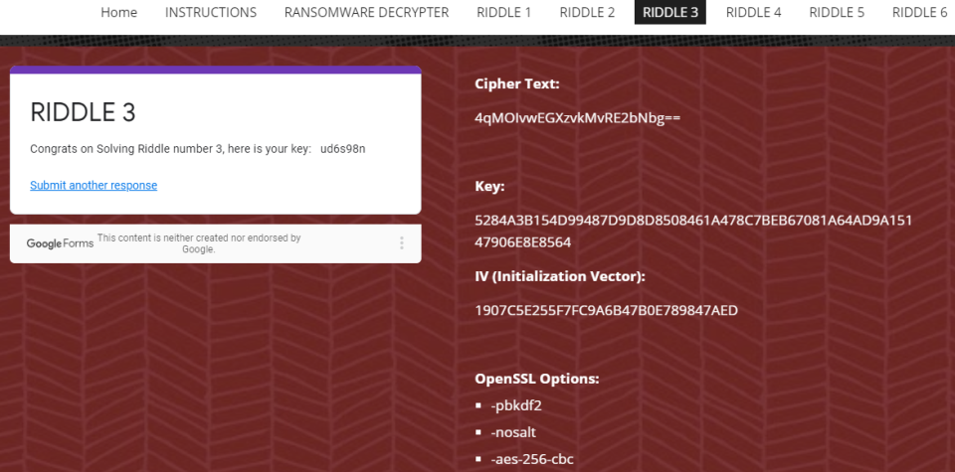

**Key** ud6s98n

**RIDDLE 4:**

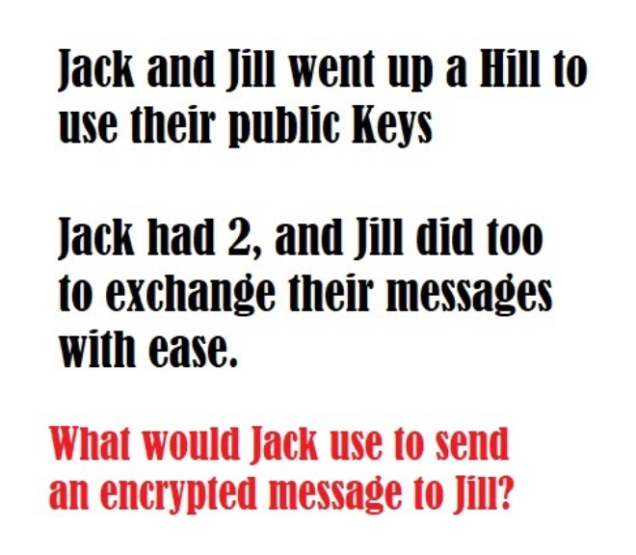

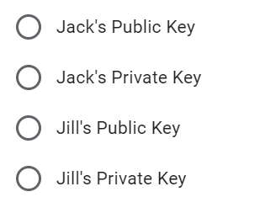

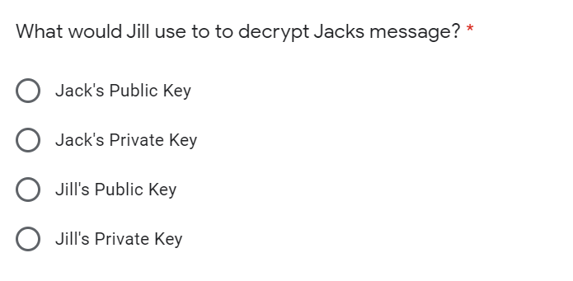

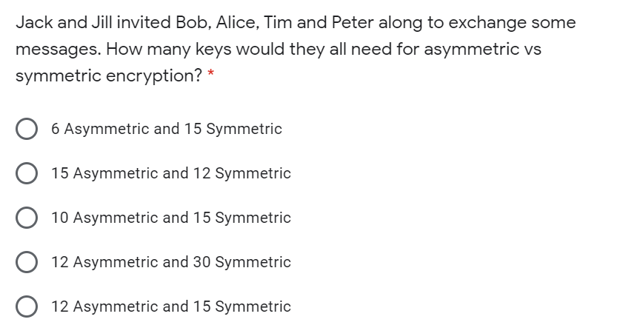

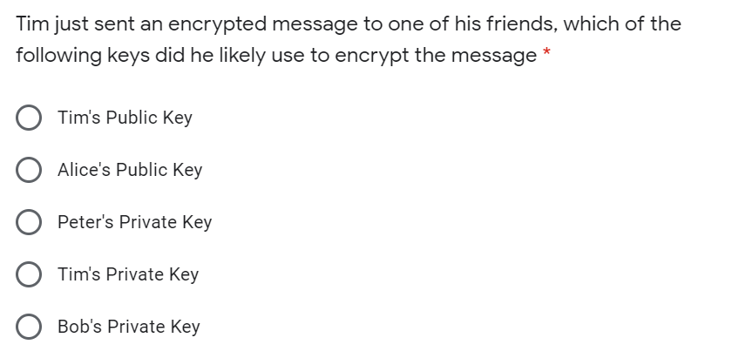

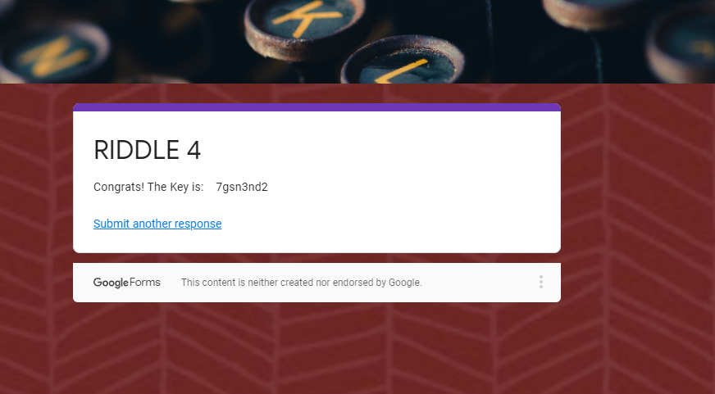

**Key** 7gsn3nd2

**RIDDLE 5:**

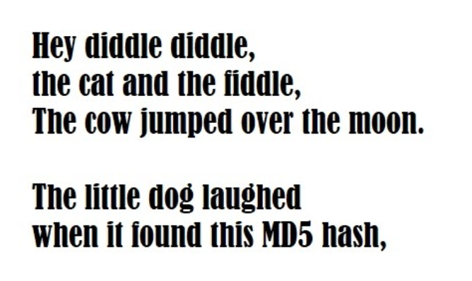

Hash:

3b75cdd826a16f5bba0076690f644dc7

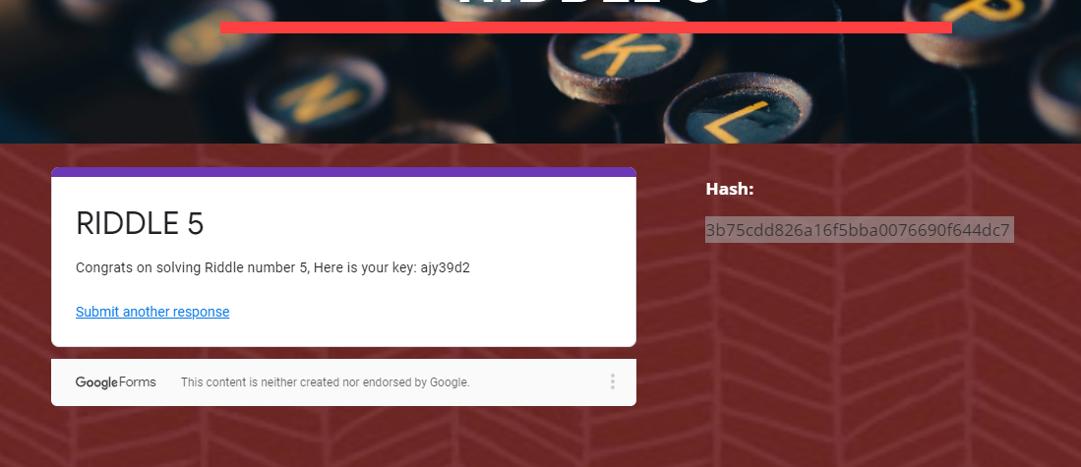

key: ajy39d2

**RIDDLE 6:**

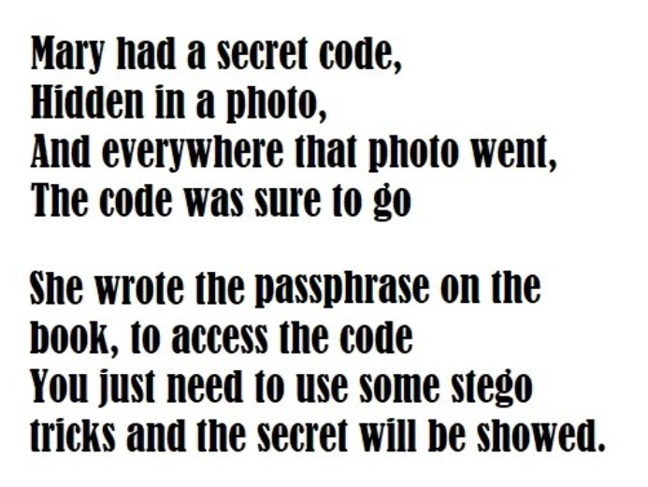

**Image Link: https://drive.google.com/file/d/1m9ykscnTGzgkkVet9wmiBCYsbhzbrKR9/view**

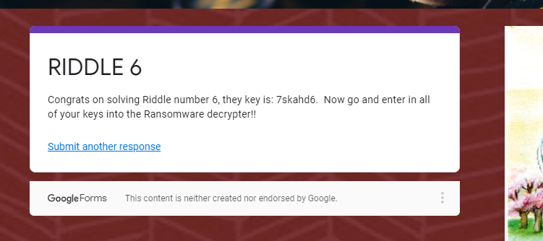

they key is: 7skahd6.

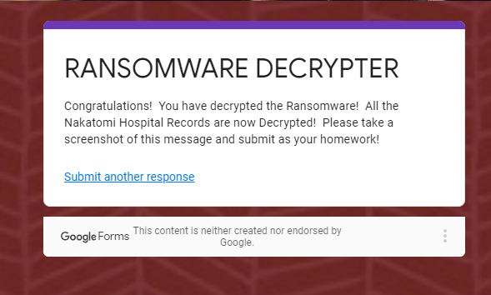

**Azure Account Set-Up**

